**Information to be recorded in the HSPB Database:**

Information should be added in real time.

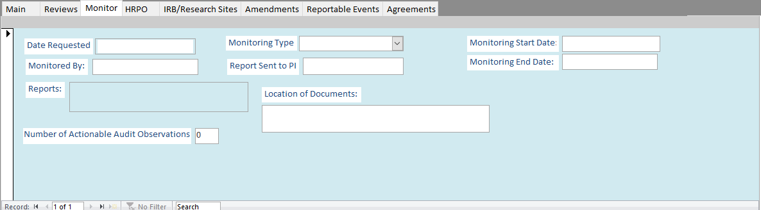

Figure 1 HSPB Database, Monitor tab

**Data Entry Key:**

|  |  |
| --- | --- |
| **Field Name** | **Data to be Entered** |
| Date Requested | The date that the monitor(s) requested scheduling for the Post Approval Compliance Monitoring (PACM) visit. |
| Monitoring Type | Drop down menu for routine PACM visit or directed PACM visit. |
| Monitored By | The names of the monitor(s) who completed the monitoring visit. |
| Completion Date | The date the PACM report was sent to the Principal Investigator (PI), study team, and Human Subjects Protection Branch point of contact (HSPB POC). |
| Monitoring Start Date | The date the monitor(s) received all applicable and required documents necessary to complete the PACM report. |
| Reports | An attachment field for the entry of the PACM report that was sent. |
| Location of Source Documents | The location that the PI and study team keep documents. |
| Comments | Communications tracking log regarding scheduling and pertinent queries. |